***Dt : 5/5/2022***

***Assignment:(Solution)***

***Program : DemoVariables2.java***

***class DemoVariables2***

***{***

***static int a=12,b=13,c;***

***int x=10,y=20,z;***

***public static void main(String[] args)***

***{***

***c = a+b;***

***System.out.println("Sum="+c);***

***DemoVariables2 ob = new DemoVariables2();***

***ob.z = ob.x*ob.y;***

***System.out.println("Mul="+ob.z);***

***}***

***}***

***o/p:***

***Sum=25***

***Mul=200***

***Diagram:(Demonstrating the Memory Location of Variables)***

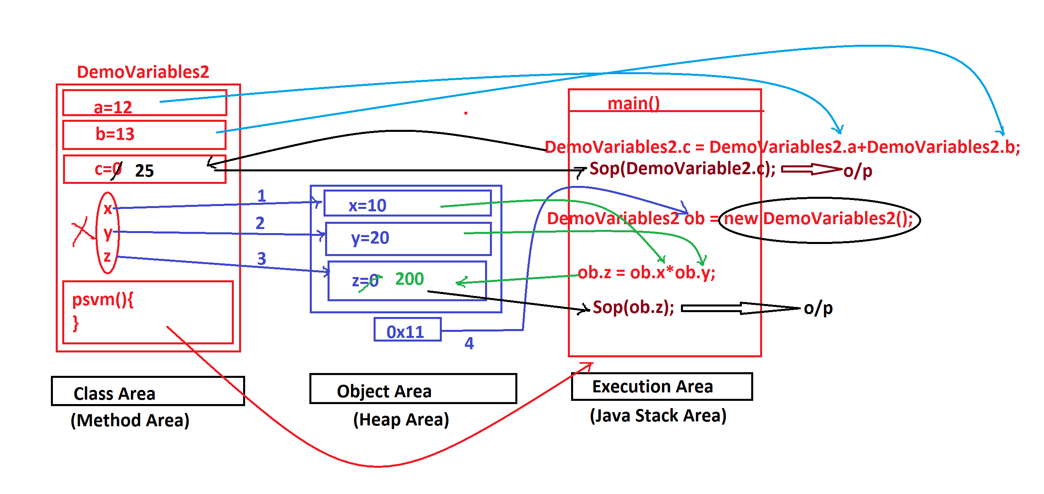

***=======================================================***

***\*imp***

***Methods in Java:***

***=>Methods are the actions which are performed on data to generate***

***results.***

***=>Based on static keyword the methods are categorized into two***

***types:***

***1.Static methods***

***2.NonStatic methods(Instance methods)***

***1.Static methods:***

***=>The methods which are declared with 'static' keyword are known***

***as static methods or Class Methods.***

***=>These static methods will get the memory within the class while***

***loading and can be accessed with Class_name.***

***structure of static methods:***

***static return_type method_name(para_list)***

***{***

***//method_body***

***}***

***Coding rule:***

***=>Static methods can access static variables directly,cannot***

***access Instance variables directly.***

***------------------------------------------------***

***=>Static methods are categorized into two types:***

***(i)Pre-defined static methods***

***(ii)User defined static methods***

***(i)Pre-defined static methods:***

***=>The static methods which are available from JavaLib are***

***known as Pre-Defined static methods or Built-in static methods***

***(ii)User defined methods:***

***=>The static methods which are defined by the user are known***

***as User defined static methods.***

***===========================================================***

***2.NonStatic methods(Instance methods):***

***=>The methods which are declared without static keyword are***

***known as NonStatic methods or Instance methods or Object methods.***

***=>These instance methods will get the memory within the object***

***while object creation and can be accessed with Object_name.***

***Structure of Instance methods:***

***return_type method_name(para_list)***

***{***

***//method_body***

***}***

***Coding Rule:***

***=>Instance methods can access both static and Instance variables***

***directly,because Instance method belongs to Object and Object***

***belongs to class.***

***-------------------------------------------------------***

***=>These Instance methods are categorized into two types:***

***(i)Pre-defined Instance methods***

***(ii)User defined Instance methods***

***(i)Pre-defined Instance methods:***

***=>The Instance methods which are available from JavaLib are***

***known as Pre-defined Instance methods or Built-In instance methods***

***(ii)User defined Instance methods:***

***=>The Instance methods which are defined by the programmer(user)***

***are known as User defined Instance methods.***

***===========================================================***